***E-Commerce Website Design***

**Introduction -**

This report will be discussing the design and functionality of the E-Commerce solution. It will also examine the strategies employed and the impact of E-Commerce on business organisations.

**Homepage Design**

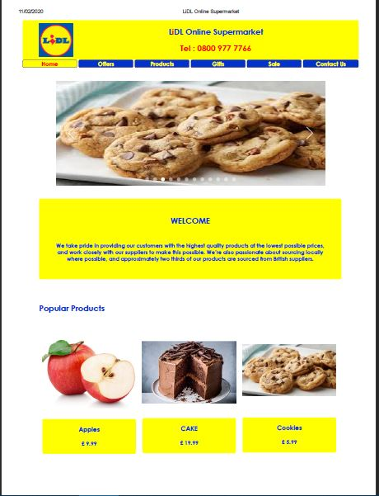

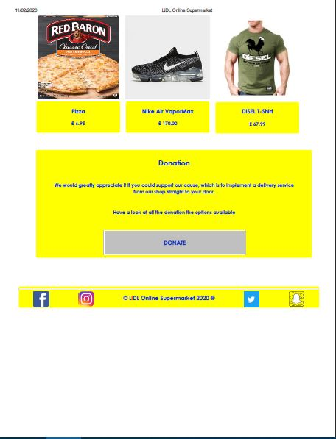

**Product Pop-up**

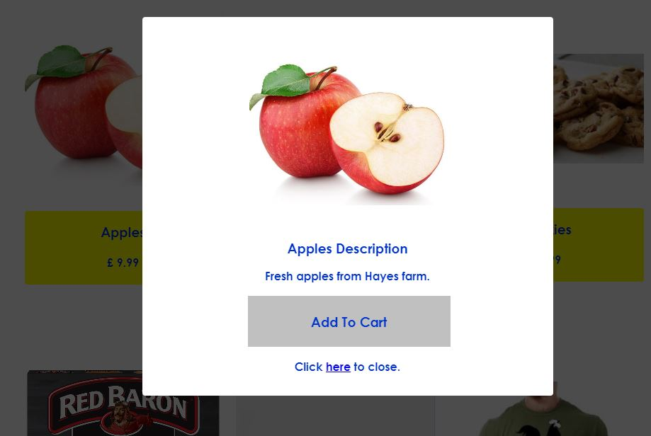

**Item Added**

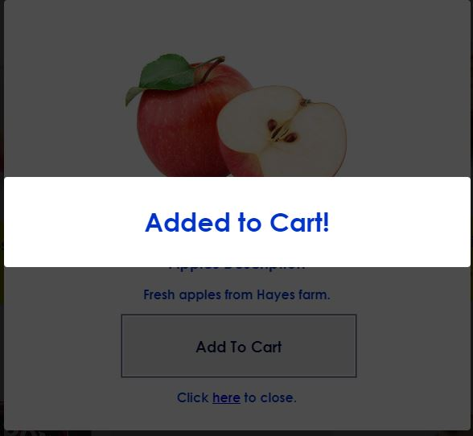

**Payment Box**

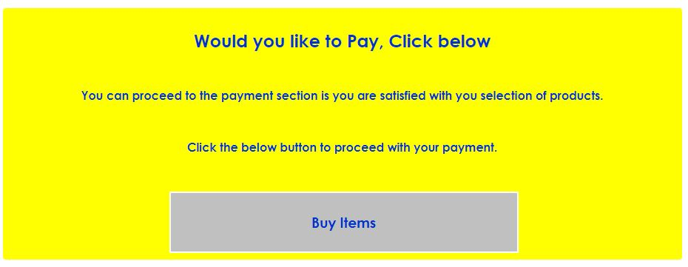

**Payment Accepted**

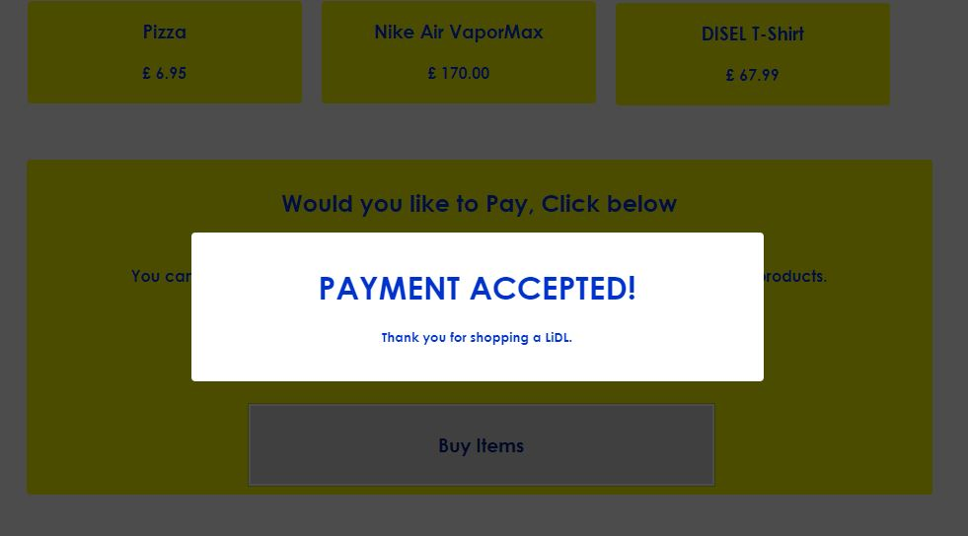

**Donation Box**

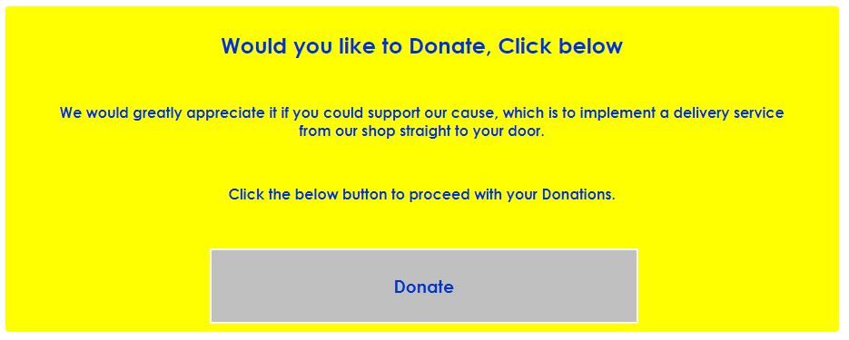

**Donation Successful**

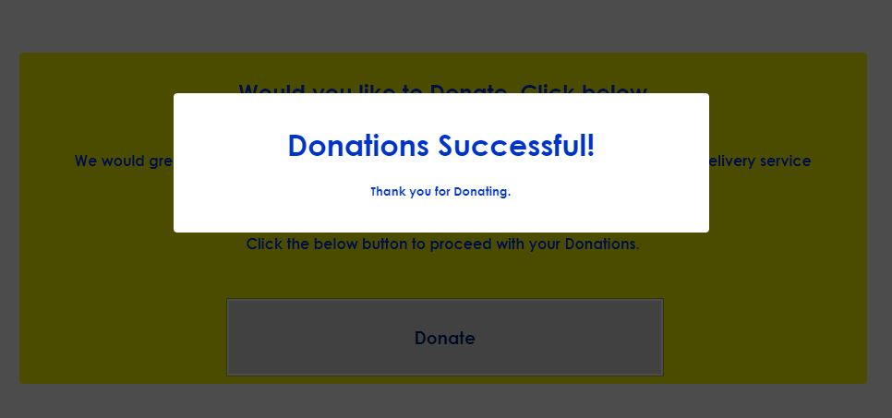

**Social Medias -**



**Conclusion -**

In conclusion, this report will be discusses the design and functionality of the E-Commerce solution. It will also examine the strategies employed and the impact of E-Commerce on business organisations.